**Assignment – 2**

**Data Scavenger Hunt**

There is a total of five matrices, defined in the dataset. The dimension of the first three matrices is two dimensional. The matrix available in the data is LA, RA, and RV. There is a total of 65 instances present in the data. After generating a total of 65 instances images with LA, RV, and RA in the same file, there are different patterns available in the data. Going through the individual images and make comparisons is possible for the small amount of the dataset. But if we have a large dataset with around 1000 images it's hard for the human to analyze each and every data instance. One of the methods to improve the visualization technique to make the waveforms comparisons more meaningful is to plot all of the instances using for loop in the code snippet. The variation with different colors is easy to analyze and draw out the results. It can be seen in the figure below.

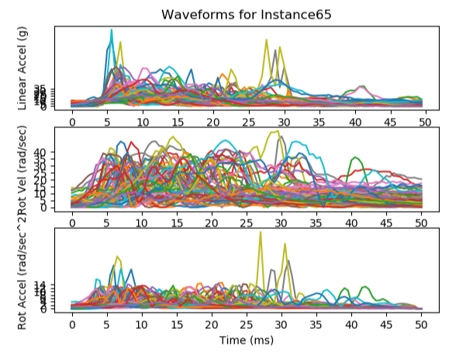

The creation of each feature depends on the definition of the 9 features extracted from Rotational Acceleration, Rotational Velocity, and Linear Acceleration. The array of the list is defined in such a manner with Min, Max and Mean function of the number of instances. The range of values depends on their min and max values as plotting is done, with that set of data. Each feature has a different set of ranges. The range comparison can be defined by the pattern of other features.

|  |  |
| --- | --- |
| **Feature** | **Instance Numbers of Top 5 largest feature values** |
| PLA | 7,8,18,19 |
| PRV | 7,8,59,10,33 |
| PRA | 7,8,18,19 |

The selection of the three features is PLA, PRV, PRA. The other features that are neglected are MLA, MRA, MRV which holds the data that is 0. The ALA, ARV, ARA are neglected because they hold less information as it is defined by the mean of the instances.

The comparisons of the instances in PLA, PRV, and PRA is most useful as it helps the data formulation by describing the MAX function for the features. The two features that are most useful in determining the 5 instances are PLA and PRA.

